Que 1. Identify what Rails generates by default

-> app/ Contains the controllers, models, views, helpers, mailers, jobs, etc.
-> config/ Contains the configuration files for the application like database.yml, routes.rb, etc.
-> db/ Contains your current database schema, as well as the database migrations.
-> lib/ Extended modules for your application.
-> log/ Application log files.
-> public/ Contains static files and compiled assets.
-> test/ Contains the test files for the application.
-> Dockerfile - Configuration file for Docker.
-> Gemfile - Lists the dependencies for the application.
-> Gemfile.lock - list of the exact versions of the gems required for the application.
-> Rakefile - A Rakefile is a file that contains tasks that can be run using the Rake command.
-> README.md - A README file that contains information about the application.
-> tmp/ Temporary files (like cache and pid files).
-> .gitignore - list of files and directories that should be ignored by Git.
-> .kamal/ - Contains Kamal secrets and deployment hooks.
-> .rubocop.yml - This file contains the configuration for RuboCop.

2. Pushed initial setup to a Git repository and raised a PR.

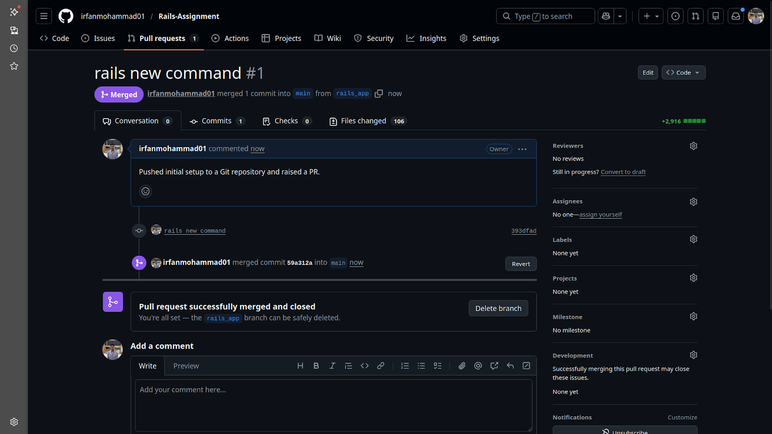

3. Explore Rails Structure: identify the purpose of app/controllers, app/models, app/views, and config/routes.rb, db/migrate

-> app/controllers - They receive requests from the browser, interact with models, and decide which view or response format to render.

-> app/models - They represent data and business logic, usually backed by a database table.

-> app/views - They contain templates that render HTML for the browser.

-> config/routes.rb - Maps incoming requests to controller actions.

-> db/migrate - contains migration files that describe changes to the database schema.

4. Explore what helper methods ActiveRecord adds automatically to both the model and the record

-> Methods added to the Model
- Blog.find_by(title: "Hello")
- Blog.where(published: true)
- Blog.create(attributes)
-> Methods added to the record
- @blog.save
- @blog.update(attributes)
- @blog.destroy

5. Explore migration helpers like add_index, rename_column

-> add_index is used to add an index to a database column.
Syntax: add_index :table_name, :column_name

-> rename_column is used to change the name of an existing column in a table.
Syntax: rename_column :table_name, :old_column_name, :new_column_name

-> add_column Adds a new column to an existing table.
Syntax: add_column :users, :age, :integer

-> remove_column Removes the column from the table definition.
Syntax: remove_column :users, :age

-> change_column Changes the data type of a column.
Syntax: change_column :users, :age, :string

-> add_reference is used to add a foreign key relationship between two tables
Syntax: add_reference :table_name, :reference_name, foreign_key: true

6. Add a published scope to blog model

-> Scope defines a reusable query on your model.
scope :published, -> { where(published: true) }

7. Verify validations using a valid method on the console.

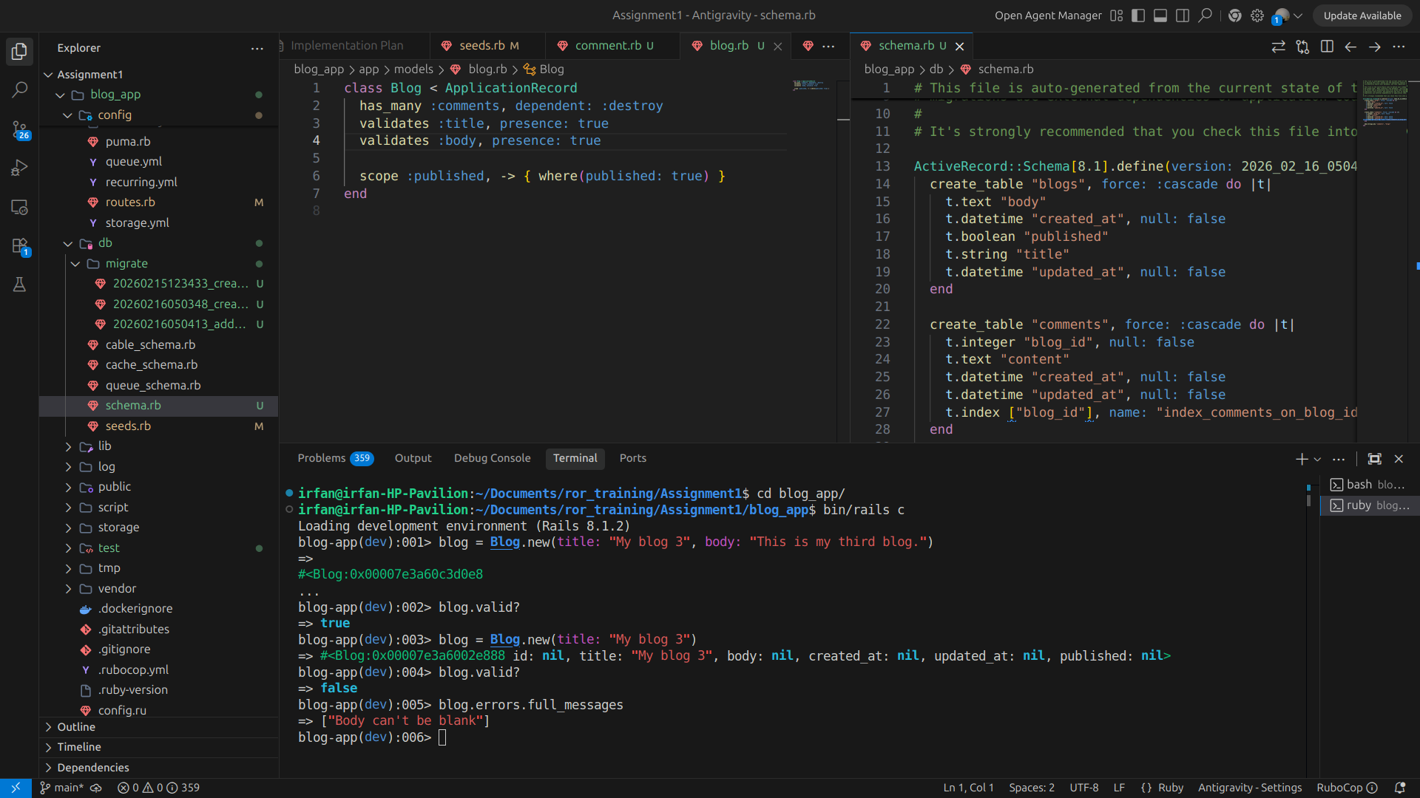
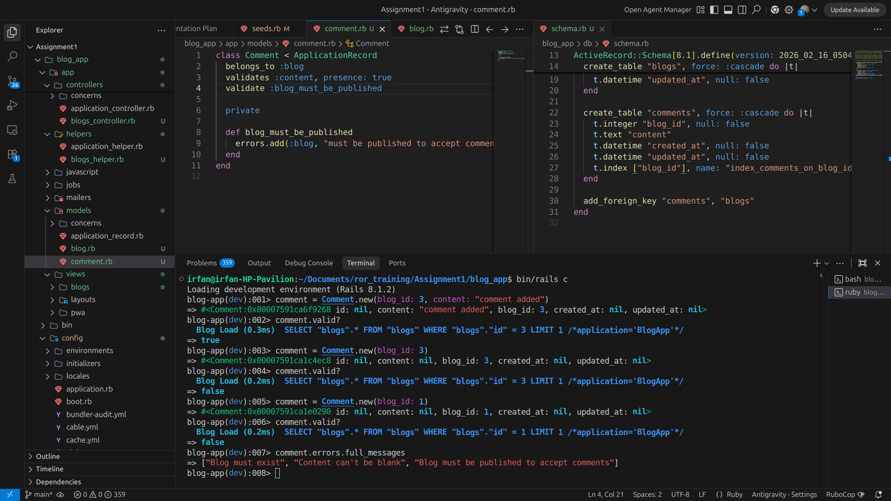

8. Explore other validation helpers

-> Validates :age, numericality: true #Ensures the value is a number.
-> validates :status, inclusion: { in: ["active", "inactive"] } # inclusion
-> validates :username, exclusion: { in: ["admin", "superuser"] } # exclusion
-> validates :email, format: { with: URI::MailTo::EMAIL_REGEXP } #regular expression.

-> Custom Validators
class MyValidator < ActiveModel::Validator
def validate(record)
end
end

class Person < ApplicationRecord
validates_with MyValidator
end
9. Explore other lifecycle callbacks
class User < ApplicationRecord
before_create :set_default_role
around_create :log_creation
after_create :send_welcome_email

private
def set_default_role
self.role = "user"
Rails.logger.info("User role set to default: user")
end

def log_creation
Rails.logger.info("Creating user with email: #{email}")
yield
Rails.logger.info("User created with email: #{email}")
end

def send_welcome_email
UserMailer.welcome_email(self).deliver_later
Rails.logger.info("User welcome email sent to: #{email}")
end
end

Callbacks for Creating an Object
Before_validation, after_validation, before_save, around_save, before_create, around_create, after_create, after_save, after_commit / after_rollback

Callbacks for Updating an Object
before_validation, after_validation, before_save, around_save, before_update, around_update, after_update, after_save, after_commit / after_rollback

10. Use AR method on rails console: where, find_by, limit
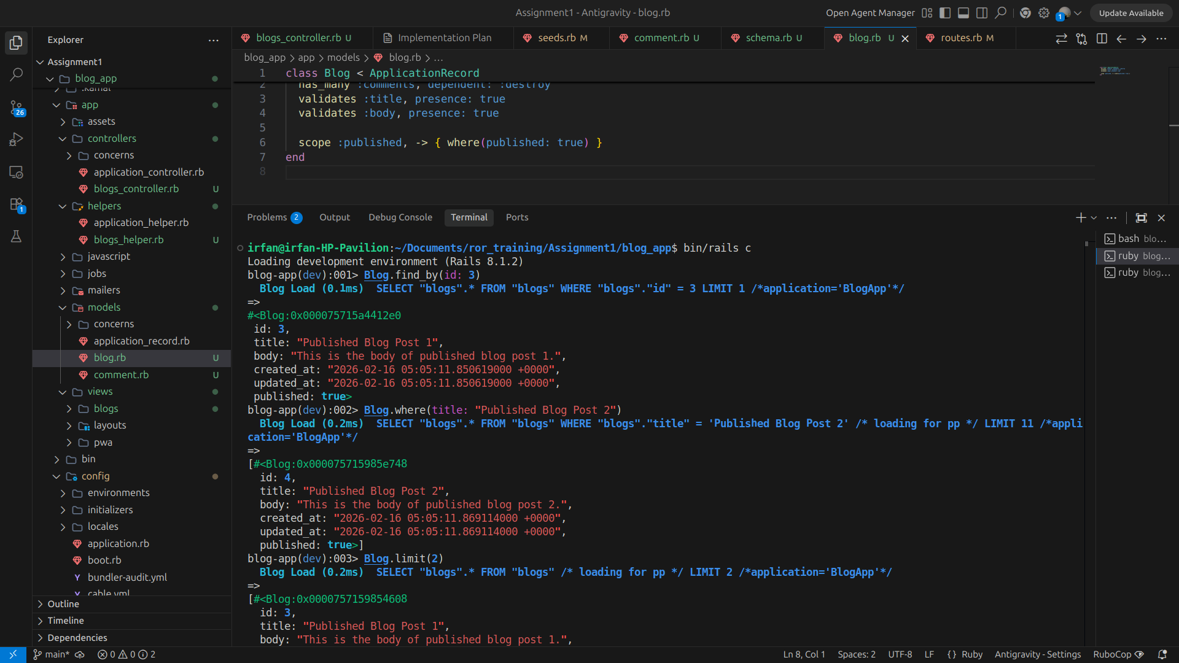

11. Explore order, joins, includes, eager_load, Identify the difference between includes and eager_load
-> Order to sort results.
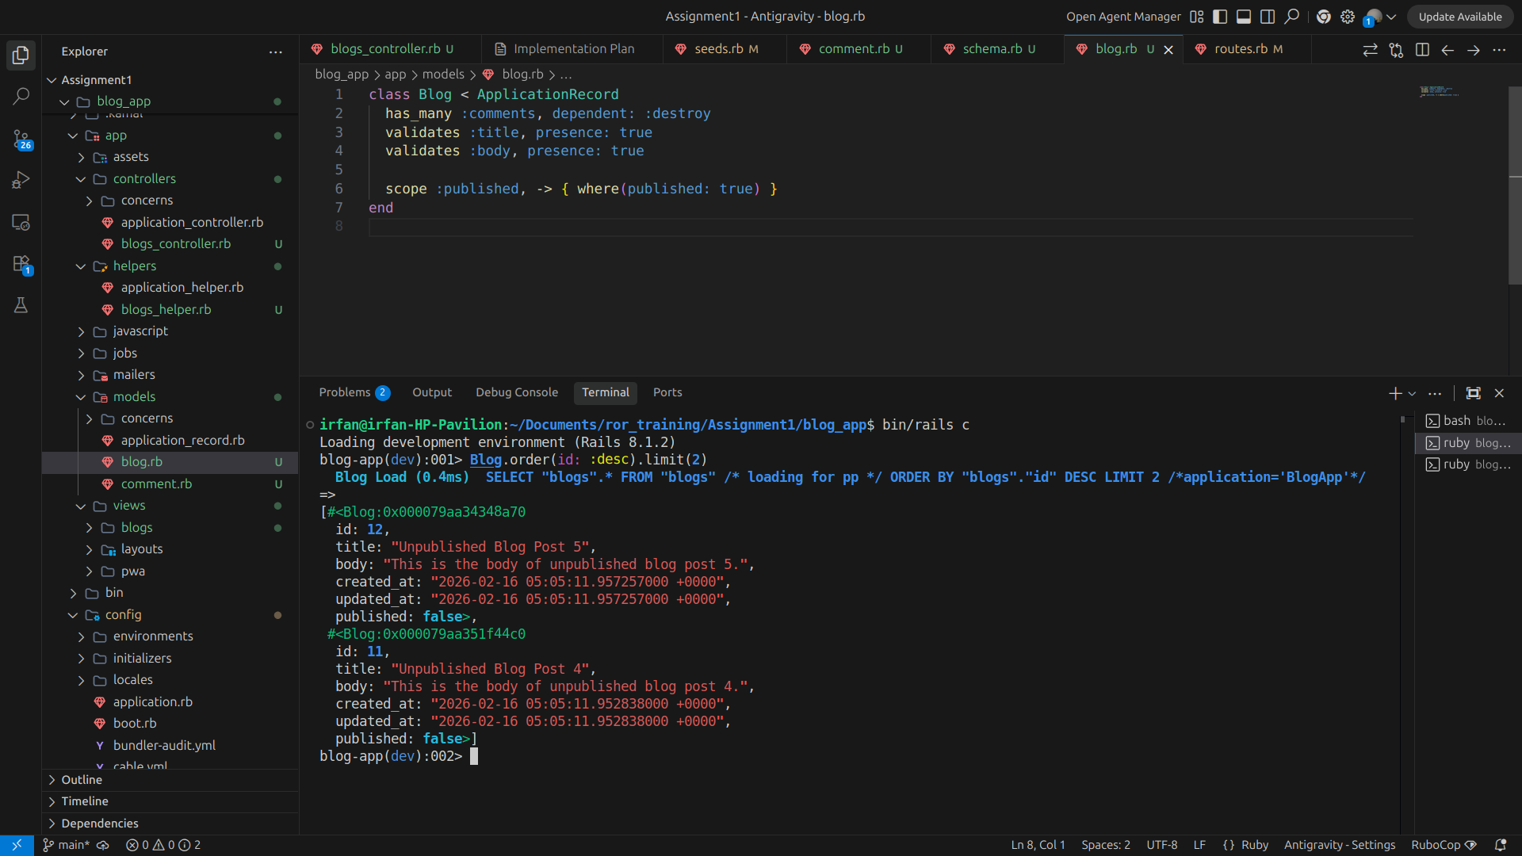

-> joins - used to perform INNER JOIN between tables, only returns records that have matching associated records and does prevent N+1 queries automatically.

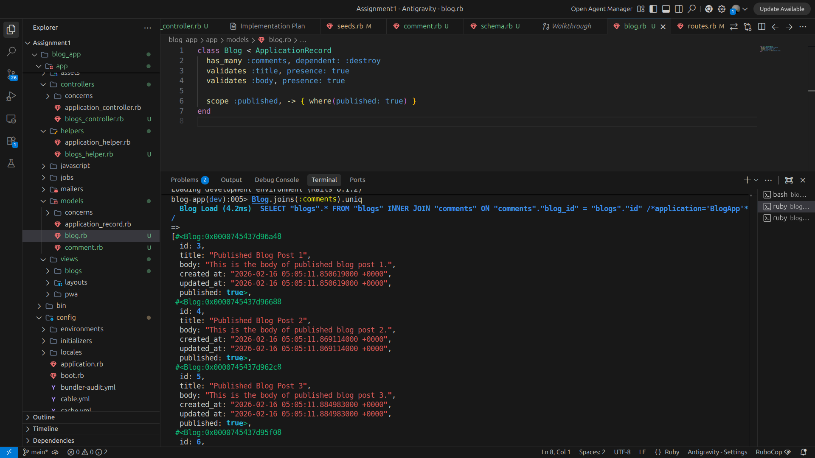

-> includes - The includes method is used for eager loading associations to prevent N+1 queries. Rails loads associated comments in advance.
blogs = Blog.includes(:comments)
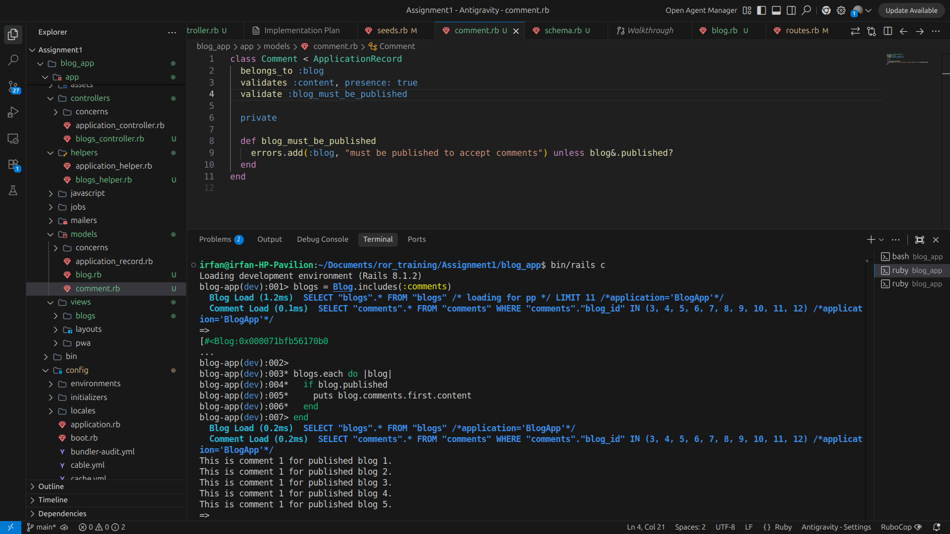

-> eager_load - The eager_load method also prevents N+1 queries but uses LEFT OUTER JOIN.
blogs = Blog.eager_load(:comments)
- Generates a LEFT OUTER JOIN query.
- Loads everything in a single SQL query.
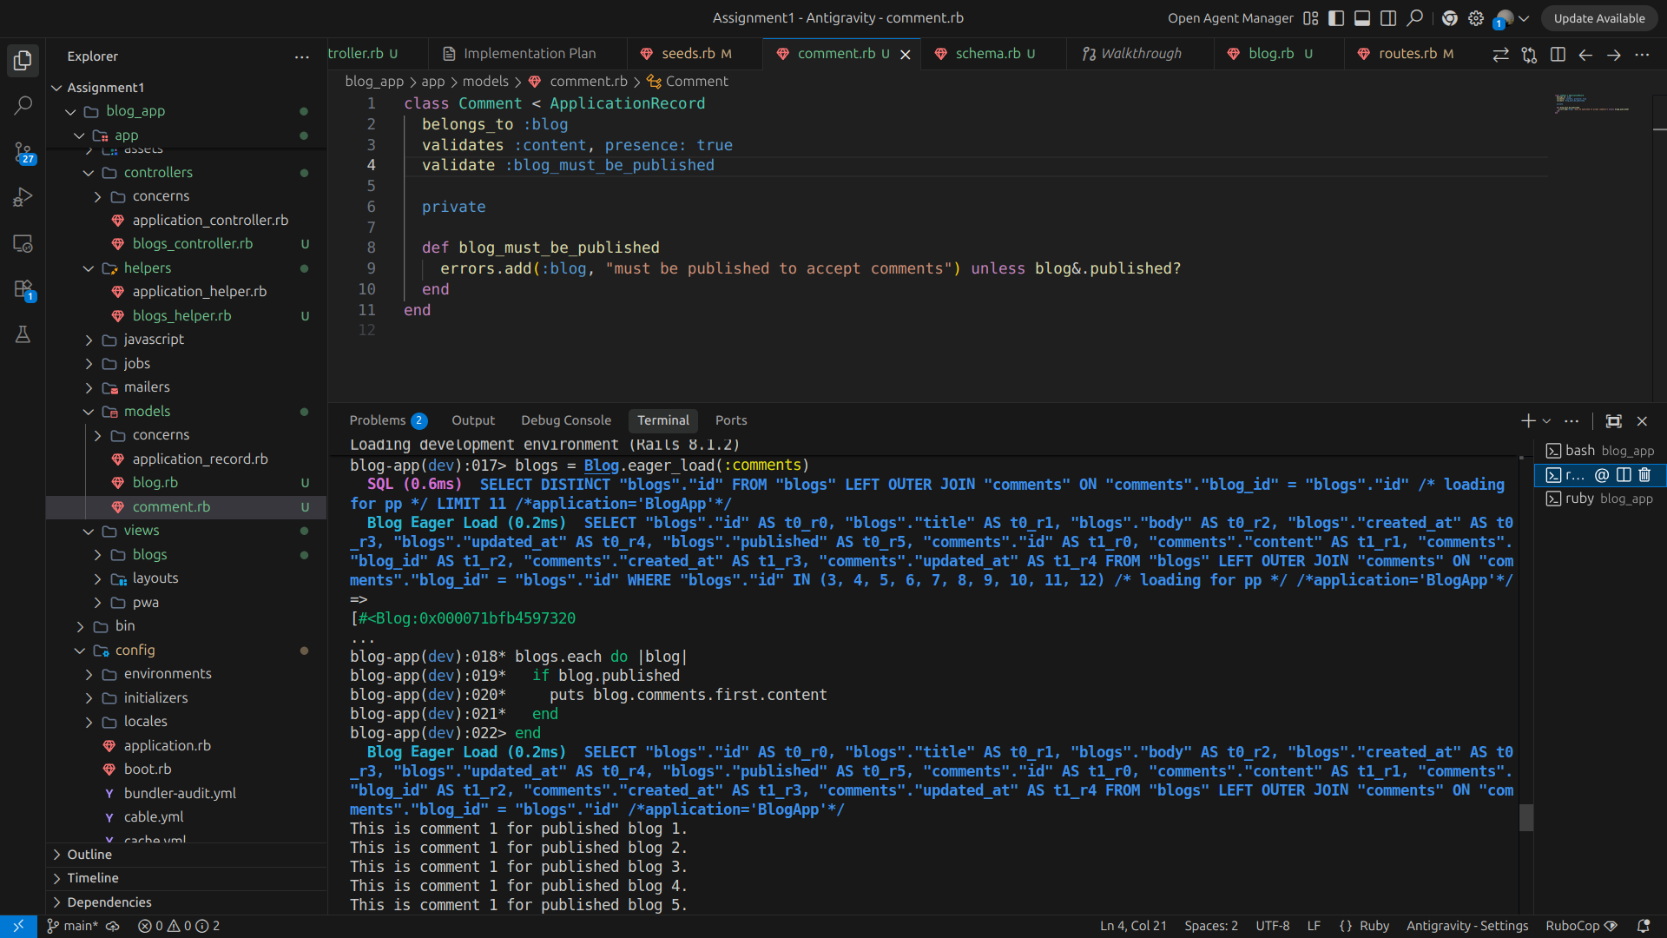

Difference between includes and eager_load

blogs = Blog.includes(:comments)
blogs.each do |blog|
if blogs.published
puts blog.comments.first.content
end
end

>> The code above executes two queries, the parent and the associated record:
i) SELECT * FROM blogs
ii) SELECT * FROM comments WHERE blog_id IN (…)

blogs = Blog.eager_load(:comments)
blogs.each do |blog|
if blogs.published
puts blog.comments.first.content
end
end

>> Query Executed
i) SELECT blogs.*, comments.*
FROM blogs
LEFT OUTER JOIN comments ON comments.post_id = blogs.id

12. Explore seeds, and try to create 10 blogs(5 published, 5 unpublished) with comments.
->
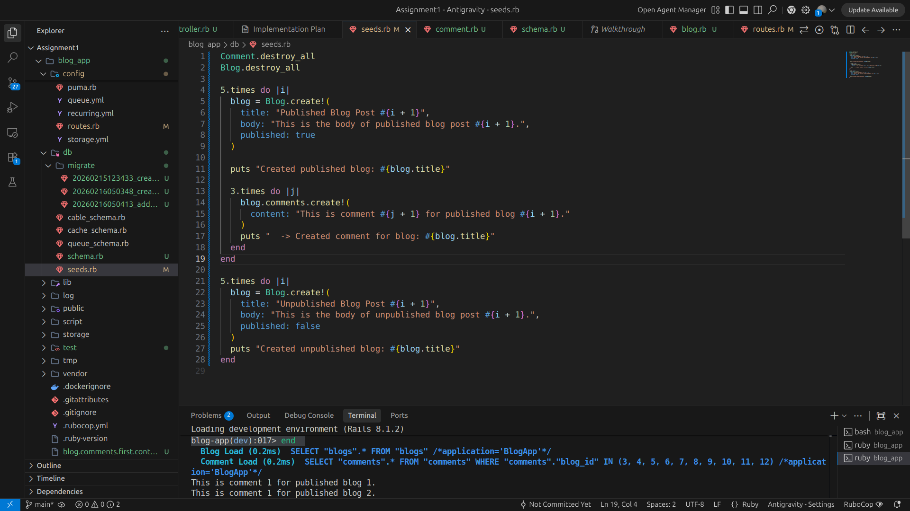

13. Verify routes using rails routes
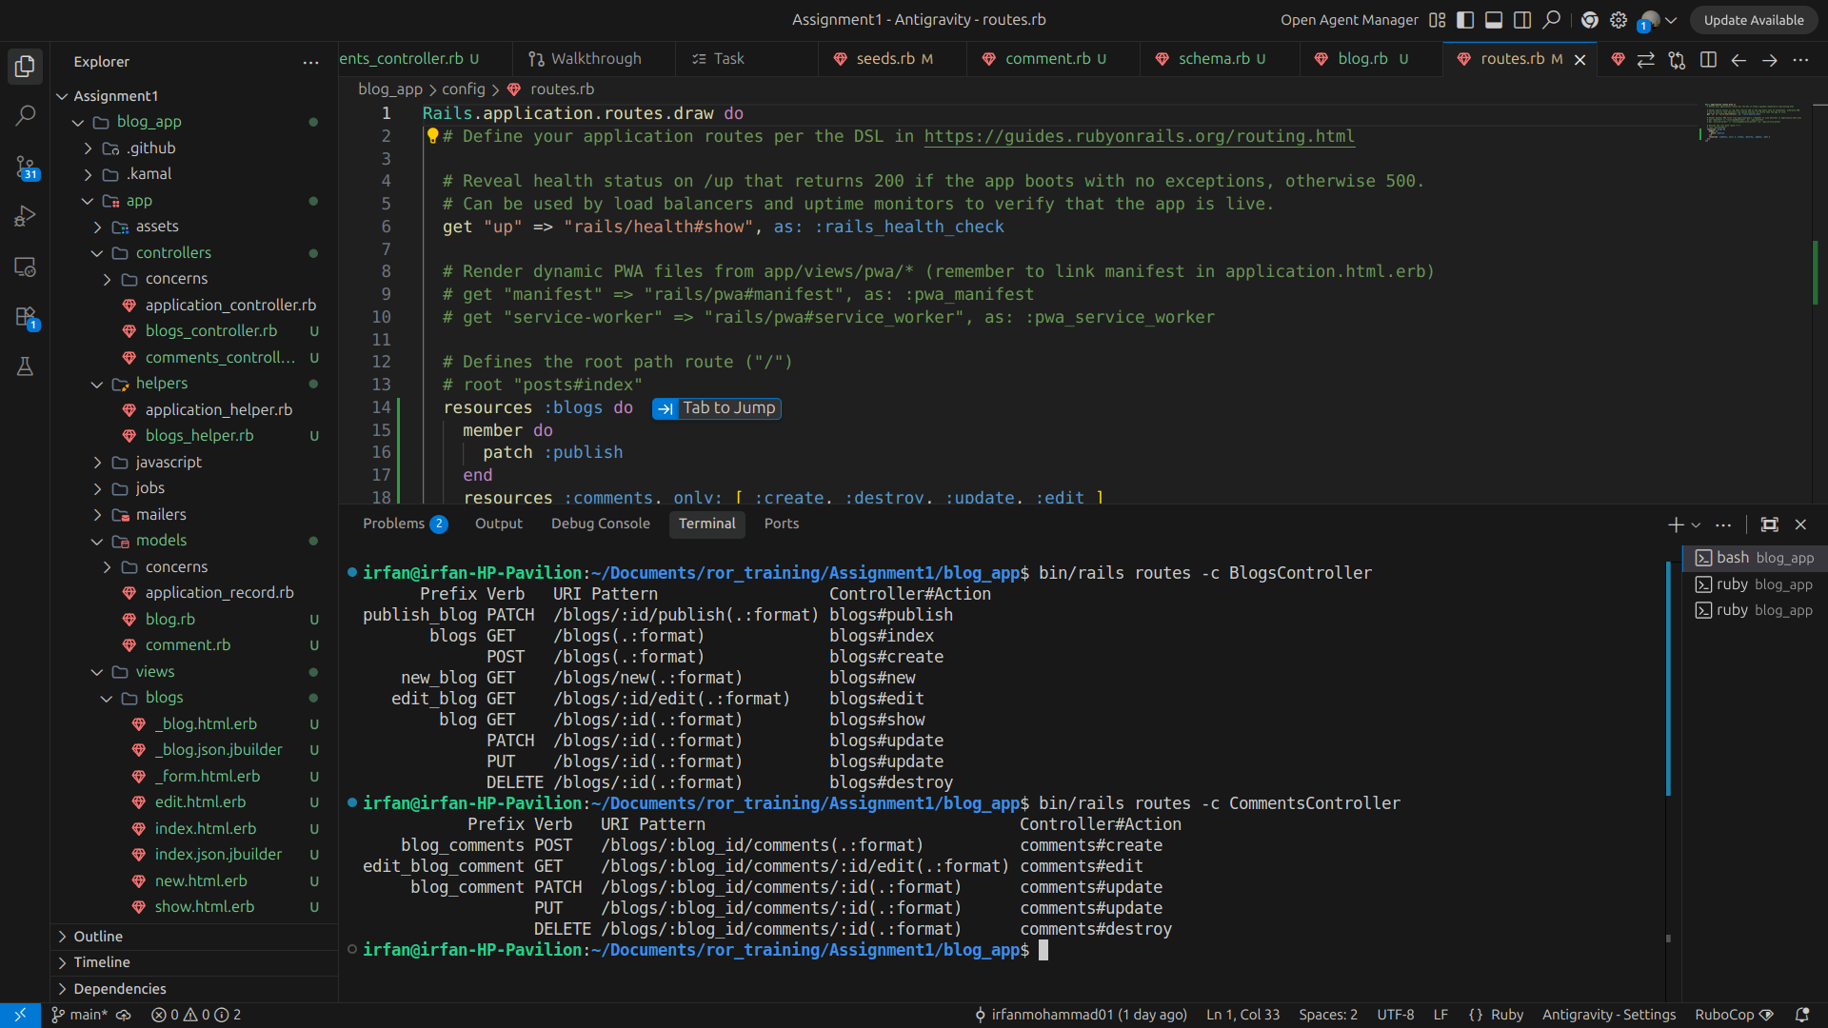

14. Explore resources vs resource and namespace vs scope.
Resources represent collections of objects, where each item has its own identifier, because a blog has many comments.
resources :blogs do
member do
patch :publish
end
resources :comments, only: [ :create, :destroy, :update, :edit ]
end
end

POST /blogs/:blog_id/comments
GET /blogs/:blog_id/comments/:id/edit
PATCH /blogs/:blog_id/comments/:id
PUT /blogs/:blog_id/comments/:id
DELETE /blogs/:blog_id/comments/:id

Resource represents a single object that does not need an ID in the URL. Rails assumes there is only one instance of that resource per context
resource :profile
Because a user has only one profile.
GET /profile/new profiles#new
POST /profile profiles#create
GET /profile profiles#show
GET /profile/edit profiles#edit
PATCH /profile profiles#update
DELETE /profile profiles#destroy

15. Implement strong parameters.

-> Strong parameters are essential for preventing mass assignment vulnerabilities. Without strong parameters, a malicious user could potentially update attributes that should not be accessible, such as admin status or other sensitive information. For instance, without strong parameters, a user could send a request like POST /users?user[admin]=1 and gain admin privileges.

def comment_update_params
params.expect(comment: [ :content ])
end

def update
@comment.update(comment_update_params)
redirect_to @blog, notice: "Comment was successfully updated."
end

